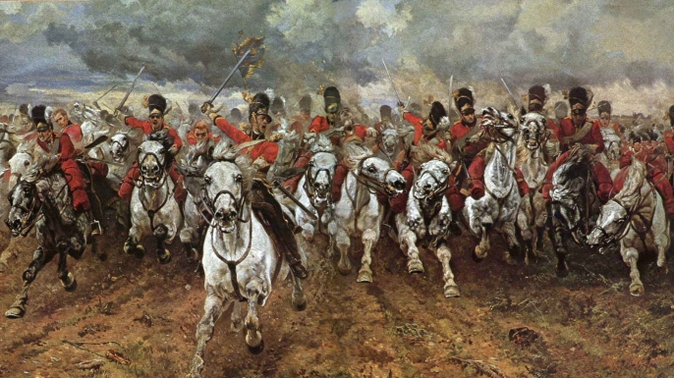
Charge of the Light Brigade

The Charge of the Light Brigade was a charge of British light cavalry against Russian forces in 1854 during the Crimean War. Due to miscommunication in the chain of command, the Light Brigade was sent on a frontal assault against an artillery battery.

The brigade suffered 118 men killed, 127 wounded, and about 60 taken prisoner. The Russian commanders initially believed that the British soldiers must be drunk. Let’s not do that on this trip.

Horsemanship Merit Badge Trip
January 22 - 24, 2021

Limited to 30 riders for the weekend. Scouts have priority.
Trip Leader:
Matthew Smith
msmith@reesegroupinc.com
C: 615.969.0662
Call or email with questions

Location:
Southeast Pack Trips
125 Kenneth Drive
Jamestown, TN 38556

Larry McMillan
O: 931.879.2260
C: 931.239.5684

Southeast Pack Trips is near the Big South Fork National River & Recreation Area

Departure:
Friday, January 22
- Meet at FHUMC at 4:00 p.m.
- Leave FHUMC at 4:30 p.m. sharp
- Drive to Southeast Pack Trips
- Stop for dinner on the way, so bring cash
- Arrive at Southeast Pack Trips around 7:30 p.m.
- Patrols will camp in fields on the outfitter’s property

Plan: This a car camping trip
Saturday, January 23
- Cook breakfast by patrol
- Cover the horsemanship merit badge materials (requirements are attached). Classes will begin at 7:30 AM.
- Lunch as one group
- Split into two groups - each group will do a 2-hour trail ride in turn
- Saturday evening camps at the outfitter’s property

Meals:
- Grubmasters: Meal group assignments will be based on patrols. The Troop will purchase the food.
- Grubmasters will cook Saturday breakfast, lunch, and dinner and Sunday breakfast at the campsite
- Grubmasters should be prepared to provide Saturday lunch too, but we are checking if the outfitter provides Saturday lunch
- Adults will form their own grubmaster group.
Weather: To be updated closer to the campout.
- The current forecast is for temperatures from the mid-40s to the low-60s, but it could be much colder
- Rain is expected at some point
- Conditions can change quickly, so be prepared
- We will monitor the weather closer to our departure date

Gear:
- Wear full-length clothes and shoes that will protect you when riding through the woods
- Wear layers that can be removed as needed
- Bring rain gear
- Bring warm clothes for Friday and Saturday night
- We may need to carry our gear to the camping area, so pack in a way that you can carry your gear
- Tents

- Things to bring individually or by patrol:
  - Individual
    - Water bottle(s) and snacks
    - Protective clothing
    - Rain gear
    - Change of clothes, socks (there is a chance of rain)
    - Flashlight
    - Camping gear: tent, ground cover, sleeping bag, sleeping pad
  - Group:
    - We should have access to water at the campsite
    - Tarps in case we have to cook in the rain
    - Cooler(s)
    - Stove, table, fuel, and matches
    - Rope/Twine

Return:
Sunday, January 24
- Cook breakfast by patrol
- Depart from the campsite with assigned carpools at approximately 9:00 a.m.
- Depending on timing some carpools might stop for lunch, so bring cash
- Arrive at FHUMC at approximately noon

Cost:
- Bring money for dinner on Friday dinner and lunch on Sunday
- The fee for horseback riding and food is around $100 per person. Bob Porter will collect after the campout after all bills are final.

